1. Case Study

We describe an industrial case from business process outsourcing (BPO) industry to illustrate the conceptual model described in figure 2. In BPO domain, Customer organisations outsource their business processes to Service Provider organisations for cost optimization, process transformation and other benefits whereas the service provides serve customers to earn revenue, profit margin, etc.

An outsourcing deal starts with a customer inviting bid for a business process. This phase is known as RFP (Request for Proposal) phase. All interested service provides bid for RFP by proposing their offerings and credibility. The offering information includes the number of full time employees (*FTEs*) to be deployed on the outsourcing process, *billing rate* (i.e. per hour rate) of FTEs, and other value proposition; the credibility information include the *Capability Ranking* (i.e. ranking as per independent agency such as analysts), *Track Record* (i.e. how many outsourcing deals completed and customer feedback), and their strengths like number of capable employees, domain knowledge, etc. The bidding for RFP is done in *bidding phase*. At the end of bidding phase, the customer evaluates all bids and identifies a service provider for outsourcing. Customer commonly uses *Capability Ranking*, *FTE Count* (i.e. full time employees to be deployed on the outsourced process), *Billing Rate*, and *Market Influence* (i.e. perception of the market as regards delivery certainty with acceptable quality) factors for evaluating a bid. The other soft issues such as familiarity with the processes being outsourced, rapport with the service provider etc., also play a part in selection of the service provider. The next phase of BPO is *servicing* phase wherein selected service provider serves customer for agreed contract period. It is common observation that BPO contracts come up for renewal after 3-5 years. Customer may renew the contract with the existing service provider on modified terms (typically advantageous to the customer) or may opt for rebidding. Factors influencing the renewal decision are reduction offered in FTE Count, Billing Rate, number and degree of escalations, perception the external agent has as regards ability to meet the project requirements etc. Contracts that fail to get renewed become candidates for later bidding. Figure F1 shows a representative state transition diagram of BPO business.

This problem space can be viewed as an actor-based event-driven system as proposed in figure 1 wherein all active elements such as customers, service providers and business processes are autonomous, adaptable, reactive and modular units. These units have their own goals and they often interact, compete, collaborate and negotiate with other units for achieving their goals. We model BPO environment as a set of customer (C) units, business processes (BP) units and service providers (SP) units. The goals of customer units are cost saving and improve effectiveness, the goals of service provider units are increasing revenue, realisation (i.e., revenue per FTE per hour) and size in terms of FTE numbers, whereas the goals of business process units is to optimize its operational cost.

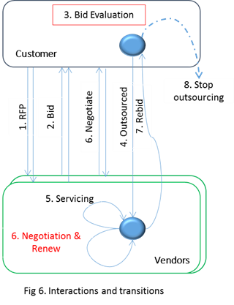 All units encapsulate their characteristics. For example, service providers encapsulate the characteristics like Capability Ranking, Billing Rate Range, FTE count, Market Influence and Delivery Excellence. Typically a characteristic variable represents a fixed value, a range of values or probabilistic distribution. For instance, Capability Ranking is a fixed value that represents one of the possible capability ranking options – *Contender*, *Challenger*, *Visionary* and *Leader*. Billing Rate Range is a range of values (e.g., 8 USD to 10 USD per hour per FTE) and Delivery Excellence attribute is a probability distribution describing confidence of delivering ‘Excellent’, ‘Normal’ and ‘Below Normal’ services.

The behavioural of units are essentially the events and event handling logics that realise the state machine depicted in figure F1. Events have a certain frequency and are stochastic in nature. In this case the customer raises RFP, all interested service providers (SPi ∈ SP) respond to the RFP event by picking suitable values from their characteristics variables. Here the interest for responding to a FRP is a stochastic behaviour. Bid evaluation function is a weighted aggregate of the various elements of RFP response (i.e., Bid) and a random value to capture effect of inherent uncertainty. The service provider with the lowest computed value of a bid wins the outsourcing deal which gets executed by selected service provider. The decision to renew existing contract is modelled on similar lines but with a different set of characteristic attributes influencing the decision. Here too, we take cognizance of incomplete and uncertain knowledge about the problem domain by introducing a random variable in the evaluation function.

The environment where these units operate exhibits temporal dynamism and stochastic behaviour. The new processes may emerge as candidates for outsourcing and some of the existing processes no longer need to be outsourced as, say, technology advance eliminates the need for human intervention in the process thus making it straight-through. The existence of customers and service providers may also change with the time.

While operating in an environment, all units develop execution trace or history. Unit evaluates its own history and the observable history (known as Measures) of other actors while reacting to an event. Unit tries to adapt suitably if it sense the goals are not achievable. In this case the service provider units are equipped with two negotiation levers namely, the productivity of FTEs, and billing rate of FTE. Service providers propose FTE productivity based on the organisational strength and decides appropriate billing rate considering market situation. Less biding rate might help to get the outsourcing deal but it impacts profitability negatively whereas more billing rate earns more revenue but impacts bid win negatively. While operating in this uncertain space, a BPO service providers need to make decisions of the following kind: *With the current strategy how much market share will they capture? What alternative strategies and levers are available? How effective will a given strategy/lever be? By when a given strategy will start showing positive impact? Will a service provider be growing at the expense of competition or vice versa?* and so on.

In the interest of space, we focus on question: *With the current strategy how much market share will they capture and how much revenue will they miss in negotiation?* We consider one service provider as ‘We’ and rest of the service providers are considered as competitors.

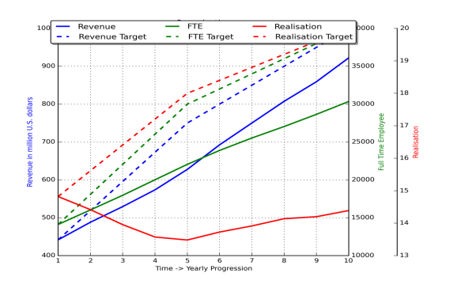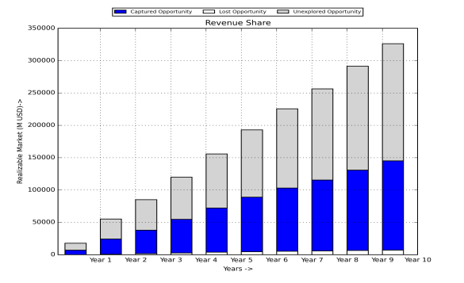We simulated above BPO environment for 10 years using proposed language and observed a set of measures which are relevant for deciding the goals of ‘We’ service provider. ‘We’ service provider has goals about Revenue, number of FTEs and Realization (revenue per FTE) as shown using blue, green and red dotted line in figure F2.

Results of the simulation run are shown in figure F2 and F3. As can be seen in figures, the current revenue of “We’ service provider is 446.5 M USD with a 60% unexplored market (as shown in figure F3). The blue color indicates the revenue of ‘We’ service provider, grey color indicate the revenue of the competitors and the white color at the bottom of the bar indicates the revenue loss. Over the years, the revenue of ‘We’ service provider is increased, the number of deployed FTEs is also increased but realisation factor is decreased to an extent as shown using in blue, green and red lines in figure F2. After 10 years, the total revenue is increased from 620 M USD to 1165 M USED, the revenue of ‘We’ service provider is also increased from 446.54 M USD to 922.28 M USD but market share is reduced from 40% to 34% of total revenue (see Fig F3). The graph in F3 also indicates a little revenue loss due to the loss in renewal process. In short, the graphs indicate many interesting aspects about ‘We’ service provider. The service provider is negotiating well in deal renewal process; however there is a significant scope for improving revenue share number of FTE and FTE realisation. Revenue share can be improved by winning more deals and FTE realisation can be increased by increasing the billing rate. However, winning more deals without compromising the billing rate is hard problem. The options such as increasing *productivity* with better resources and *market influence* should be exploited for optimum solution. We use our simulation environment to navigate solution space and decide appropriate levers that has potential to achieve organisational goals.